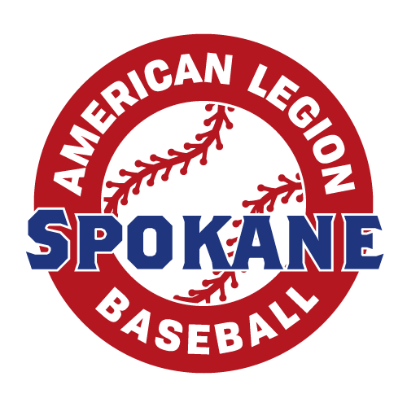

Mandatory Medical and Liability Insurance Coverage

Every American Legion Baseball team (both junior and senior) must purchase both group liability and accident insurance from The American Legion's agent of record (S.A. Van Dyk, Inc.). Coverage must be purchased on or before May 15. Violation of this rule will result in the disqualification from any further competition.

It is very important to note that if you will have a player on a Junior Team who will turn 18 during the year 2017, you must register as a senior team and purchase Senior Insurance. You can still compete in the Junior Program.

SIYB will pay for your teams insurance by May 15th. Once the policy is purchased if you have and questions visit their website at www.savandyk.com/

2017 Junior Program:
•$85.00...Liability
•$145.00...Medical Seasonal
•$25.00...Administration Fee
•$25.00...National Fee
TOTAL = $280

2017 Senior Program:
•$125.00...Liability
•$255.00...Medical Yr-Round
•$25.00...Administration Fee
•$50.00...National Fee
TOTAL = $455

